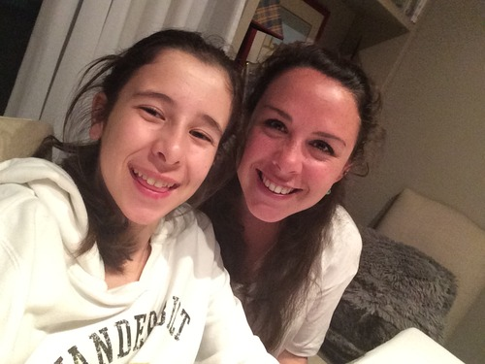
Of all the incredible experiences I got the opportunity to encounter during my time abroad – magnificent new countries, beautiful views, mouth-watering delicacies, picturesque cafes, mind-opening culture shocks, beautiful new languages, and an endless amount more – the one thing I’d have to say I value the most above anything else were the relationships I got to take away from it.
Looking back on it now as an act of fate, I signed up my first semester to do one-on-one tutoring with a couple different Spanish kids. One of the kids that I tutored was a girl named Nerea. It was immediately apparent to me when I first met Nerea that she had an uncanny talent when it came to acquiring new languages. At the age of twelve (when I met her), she already spoke Spanish (her first language), was at an intermediate level of French, was learning Basque, and was speaking English at a level that made me feel unnecessary and obsolete as her new English tutor.
Anyways, I went to Nerea’s house twice a week and over the course of the semester got to know her and her family better and better. Her mother Elena and father Nacho were two of the most kind-hearted and welcoming individuals that I had met in Spain – hell, in my entire life (not to mention their puppy, Duna). They always extended invitations for me to stay for dinner and were always thrilled to learn about me and hear about my experience in Bilbao so far. When first semester was coming to a close, I alluded to them that I had no intention of living in an apartment with Americans for another semester, expressing that I really wanted to live with a host family in order to form deeper connections with Spaniards and experience much more of the culture. Sensing my underlying desires, they asked me if I’d possibly be able to stay later that upcoming Thursday, seeing as they wanted to make me a special Basque meal and go over a few things. Much to my elated happiness, that night they formally asked me to move in with them as soon as the lease with my apartment expired so that I could be [officially] a part of the family. Needless to say, I happily accepted their invitation and went home squealing to my roommates and then to my mom via skype.
Living with them opened me up so many aspects of both the Spanish and Basque culture that I was completely blind to first semester. Whether it was eating authentic Basque cuisine (referred to as among some of the most delectable food in the world), attending Spanish birthday parties, or just a typical night of sitting on the couch and watching Modern Family (which might I say is an entirely different experience in Spanish) with my family, I truly enjoyed every day of my experience with them.
Possibly the greatest aspect of the entire experience with them was the fact that my mom (American mom, that is) got the opportunity to come to Bilbao at the end of the year and meet them. She got to see the beautiful home that I’d been living in and talk and get to know the family that took me under their wing and took care of me for the prior four months. We showed them pictures of our (Spanish) family vacation we took to go skiing in the Alps a couple months before and even introduced her to some of the extended fam. It filled my heart with joy to show my mom how my relationship with them had flourished so much over the course of my time there and continues to today (thank goodness for WhatsApp and Skype).
From my personal experience, I have to say that meeting these amazing people and being able to truly consider them my second family is one of the greatest things that I was able to take out of my time abroad, and one that I hope other study abroaders get the privilege to experience.
