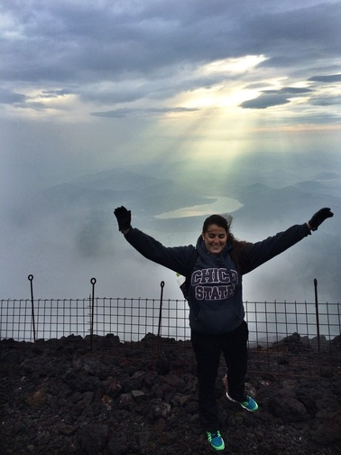
Conquering Mount Fuji
By: Alyssa Bucher
Its 4 a.m. on July 23rd, the sun will rise in thirty minutes, and I am so close to the top I can feel it. Every part of my body hurts at this point and I feel like I can’t take another step. All I am thinking of is that I need to make it to the top, I’ve come this far. But wait, before I continue on with my story, I think I should start from the beginning...
It’s the night before my adventure begins and I’m excitedly talking with other exchange students in the lobby of our apartment complex. The plans are set and we will be leaving early the next morning to begin our journey to Japan’s most famous mountain, Mt. Fuji. It will take 4 hours to get there by a culmination of the subway, train and bus. We arrived at the base of the mountain around 3pm and planned to climb through the night to see the sunrise. Because of the change in altitude we had to acclimate to the air before we could begin the climb. At 3:30pm, I began what would be the longest climb of my entire life. I had a backpack full of stuff that I thought would sustain me through the climb; some granola bars, water, winter clothes for the higher elevation and a few other miscellaneous items. Little did I know, until we were at the base of the mountain, that one of my fellow exchange students had picked the hardest trail for us to take. We had come all this way though so it was a challenge that I had to accept.
The first few hours weren’t too bad due to our excitement, energy and games that we played to pass the time. However, the terrain was not very friendly; it consisted of volcanic ash that made you slide back with every step and rocks of all sizes that would give out under your feet. Combine that with the zig-zag incline and you have yourself some burning calves and slowly beaten down spirits. We were told it would take about six hours to make it to the first base area. Those six hours came and went and we saw no rest in sight. Our pace must have been slower but the most frustrating part was seeing lights from the base in the distance but we never seemed to get closer. After eight hours we made it to a base but it was closed and the people that were there were asleep. There was a bathroom though and for a small donation you were able to use it. By this time it was around 11pm and completely pitch black on the mountain. We had our flashlights and silence of the surroundings with us now. By midnight we decided that we needed to rest for a little while. We laid down on rocks next to the trail and attempted to sleep. It was freezing cold and windy where we were at, due to the high elevation. We were so high up that there were ice chunks on the mountain that were frozen solid. We were able to sleep for 45 minutes and then we had to continue on.
At this point, it was 1am and we had been climbing for 10 hours, we were becoming overly tired and somewhat delirious. I was walking next to one of my friends and he was really struggling at this point. He is a bigger guy who is somewhere around 6 feet tall and he had not prepared well for this journey. All of a sudden he started swaying and began to tilt to the left which is the side where the mountain descends. I looked over and grabbed him by the shirt and used all my might to stop him from falling down the mountain. It was one of the scariest moments knowing that had I not noticed him about to fall he could have tumbled down the entire mountain. From there on out we had two guys by his side until we reached the next base. We finally made it to the last station around 2am. We had two and a half hours to make the last 1.5 miles to the top. This section is known as the steepest, rockiest and hardest part of the climb. Already tired and beaten up we knew this would be the biggest challenge. My friend who almost fell down the mountain decided that he would no longer continue to climb and that he would stay at the last base to rest. However, at the last base we gained a new friend who happened to be climbing alone. His name was Jeff and he was from Canada. He was climbing the mountain in Vans shoes and didn’t realize that the trail he had taken was the hardest one. He was doing really well however and gave us all great encouragement. The encouragement of others is what kept me going because there were many times in that last section where I wanted to stop. The last part of this climb seemed to go on forever and the fact that we had a time crunch didn’t help. We could now see the peak and the thought of making it to the top is what kept me going.
So here we are again, its 4am and I am so close to the top. It’s the home stretch of the climb and every step takes more effort than I ever thought possible. All of a sudden, I reached the bottom of another set of stairs and I looked up to see a Japanese gate at the top. A burst of happiness hit me and I ran the last stairs to top of the mountain. We had made it! It was exactly 4:30am and the sun was set to rise at 4:35am. By some miracle we had made it just in time for the sunrise. To my disappointment though, it was foggy that day and we didn’t get a clear shot of the sun but I still got a picture of a lifetime. Just as the fog cleared for a minute the sun shined down through the clouds onto the scenery down below. I threw my hands up in celebration and my new friend Jeff took a photo of me right at that moment. It turned out to be such a great picture and a memory that I will have forever. Jeff and I explored the top while the others slept for about an hour and I had a renewed energy from accomplishing the number one thing I wanted to do while I was in Japan. However, the journey wasn’t over...we still had to descend the mountain. It was a lot faster than the climb up but it took a different type of approach to get down. For four hours we had to run down volcanic ash that went past our ankles. It was similar to skiing down a mountain and it required a lot of focus and balance. It was easier but still difficult after just enduring the climb up the mountain. We finally made it down the mountain and a sense of relief washed over all of us. We got souvenirs, said our goodbyes to Jeff and then began our journey back to our home city.
The overall climb was a round trip of 13.8 miles and it took 17 hours; 13 to go up and 4 to get down. I stayed awake for a total of 43 hours during the entire journey. I ended up sunburnt, sore for a week and extremely tired but I gained one of the best experiences of my life. This wasn’t just a hike up a mountain; it was something much bigger than that. It challenged me, showed me what I can endure, gave me internal strength and gave me memories for a lifetime. I can never truly put into words how wonderful this experience was. None of this would have been possible for me had I not studied abroad. Studying abroad was one of the best decisions I have ever made and it changed my life for the better in so many ways. My hope is that everyone has the chance to study abroad and that, in the process of it, they can accomplish whatever goals or bucket list items that they have. I left part of myself up on that mountain, and a piece of my heart in Japan, and because of that I approach life with a changed perspective and a yearning to travel to a new destination once again.

